STUDENT AND YOUTH COMPETITIONS 2023
SHORTLISTS ANNOUNCED
EXHIBITION: 14 APRIL - 1 MAY 2023 | SOMERSET HOUSE, LONDON

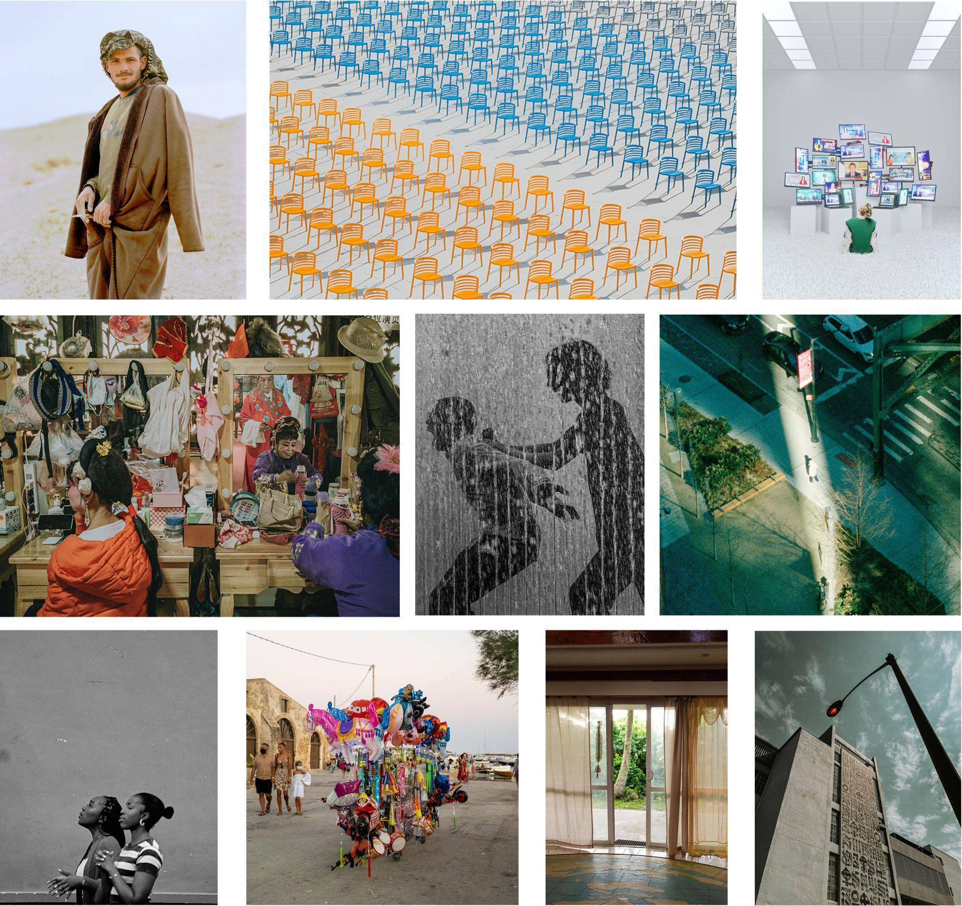
The World Photography Organisation announces today the shortlisted photographers in the Student and Youth competitions of the Sony World Photography Awards 2023. Winners of Student Photographer of the Year and Youth Photographer of the Year will be announced on 13 April and will go on display as part of the Sony World Photography Awards 2023 exhibition at Somerset House, London.

With more entries this year than ever before, the Student and Youth competitions aim to uplift the next generation of photographers and inspire them in the next steps of their photography journey.

STUDENT COMPETITION SHORTLIST

The Student competition shortlist showcases bodies of works by 10 students at leading international higher education institutions. For this year’s competition, students were invited to submit a series of five to 10 images responding to the brief In a Changing World, highlighting positive stories of development and progress from across the globe. The shortlisted work shows how these student photographers are responding to the changes in the world around them in diverse and nuanced ways.

Technological progress is examined by several of the projects, such as Encyclopedia of Technology by Bobby Cheung (China Mainland, New York University Tisch School of the Arts, USA), a series of CGI-integrated photographs encouraging us to look at how these innovations have permeated every aspect of our lives; and Resignify by Maria Camila Ramirez Castañeda (Colombia, Universidad de Antioquia), which focuses on how the city of Medellín in Colombia has redefined itself as a leading technological hub.

Elsewhere shortlisted photographers have looked at how local communities have adapted to the swift tide of change, such as in Ephemeral Freedom by Arianna Todisco (Italy, CFP Bauer) which spotlights the Caminanti community, a nomadic Sicilian ethnic minority; Keep the Yunnan Opera by Long Jing (China Mainland, Yunnan Arts University) which follows a traditional regional theatre troupe whose art form is in decline; and Born of Sand and Sun by Petra Bašnáková (Slovakia, Tomas Bata University in Zlín, Czech Republic), a series exploring the strength of the Bedouin community’s relationship to the desert, which sits at the heart of their culture and identity.

Family legacy was also the focus of several projects, including It’s a Girl Again by Lidan Xu (China Mainland, Tama Art University, Japan) which presents the photographer’s family’s enduring traditions and attitudes around gender and birth; and ZK1AA by Nelly Farmiloe (New Zealand, Photography Studies College, Australia), a series piecing together the last remaining fragments of her grandparents' lives in the Cook Islands.

Observing a world in a state of flux, several of the shortlisted photographers have also turned their cameras to the things that keep them grounded, such as in Look Up to the Sky by Amy Gajjar (South Africa, Red & Yellow Creative School of Business), which juxtaposes the local landscape against the sky above, inviting us to take a moment to appreciate the beauty that can be found in the mundane; Expressions of Worship by Mary Ashokeji (UK, Ravensbourne University London) who bears witness to the intimacy of a worship event at a local church; and Mirage by Kaiyu Dong (China Mainland, School of Visual Arts, USA), where the photographer dissects their own daily routine to find the cracks and accidents that break the repetitive pattern of our quotidian lives.

The winner of Student Photographer of the Year 2023 will be selected from the 10 students and announced at the Sony World Photography Awards 2023 ceremony in London on 13 April. The overall winning university will receive Sony digital imaging equipment worth €30,000.

This year’s Student shortlist was judged by Eliza Williams, Editor at Creative Review.

YOUTH COMPETITION SHORTLIST

The Youth competition shortlist features works by 7 photographers under the age of 19. This year, entrants were invited to respond to the theme Your Everyday and share their unique view of the world around them.

Several of the shortlisted photographers turned their cameras to fleeting childhood moments. In her photograph Liberty McAuley (UK, 15 years old) captured two children playing tag in a water fountain on a hot summer’s day. Elsewhere, Edmond Leong (Malaysia, 19 years old) catches the shifting expressions on the faces of children in a crowd scene, while Natálie Navrátilová (Czech Republic, 18 years old) ponders the world we are leaving behind for the next generation in an image of children swimming amidst plastic fish. Elsewhere, photographers turned to their environments and surroundings for inspiration, such as Hai Wang (China Mainland, 16 years old) who photographed rows of perfectly aligned and deserted chairs at a school opening ceremony, highlighting the impact of the pandemic on large social gatherings. Capturing a split-second moment from a car, Eason Zhang (China Mainland, 14 years old) photographed a dog with its head hanging out of the window, juxtaposed with the reflection of its owner in the rear-view mirror. Meanwhile Katarzyny Akermana (Poland, 19 years old) shows the wild beauty of the animal world in a dramatic image of a horse and rider, shot against the setting sun. Reflecting on identity through her self-portrait, Emily Cho (Republic of Korea, 16 years old) shows how the stresses of her studies have imprinted upon her identity.

Youth Photographer of the Year is judged by Eric Schlosser, Art Director at the Tbilisi Art Fair, Georgia. The winner will receive a range of Sony digital imaging equipment to nurture their vision.

The overall winners in the Student, Youth, Open and Professional competitions of the Sony World Photography Awards 2023 will be announced on 13 April 2023. For more information about upcoming announcements and winners please visit www.worldphoto.org

STUDENT COMPETITION 2023 SHORTLIST  Amy Gajjar, South Africa  Red & Yellow Creative School of Business, South Africa  Arianna Todisco, Italy  CFP Bauer, Italy  Bobby Cheung, China Mainland  New York University Tisch School of the Arts, USA  Kaiyu Dong, China Mainland  School of Visual Arts, USA  Lidan Xu, China Mainland  Tama Art University, Japan  Long Jing, China Mainland  Yunnan Arts University, China Mainland  Maria Camila Ramirez Castañeda, Colombia  Universidad de Antioquia, Colombia  Mary Ashokeji, UK  Ravensbourne University London, UK  Nelly Farmiloe, New Zealand  Photography Studies College, Australia  Petra Bašnáková, Slovakia  Tomas Bata University in Zlín, Czech Republic | YOUTH COMPETITION 2023 SHORTLIST  Eason Zhang, China Mainland  Edmond Leong, Malaysia  Emily Cho, Republic of Korea  Hai Wang, China Mainland  Katarzyny Akermana, Poland  Liberty McAuley, UK  Natálie Navrátilová, Czech Republic

IMAGES AVAILABLE AT PRESS.CREOARTS.COM

PRESS CONTACTS
FOR FURTHER INFORMATION, PLEASE CONTACT:
Inbal Mizrahi / Polly Brock on media@creoarts.com

NOTES TO EDITORS

ABOUT SONY WORLD PHOTOGRAPHY AWARDS
Produced by the World Photography Organisation, the internationally acclaimed Sony World Photography Awards is one of the most important fixtures in the global photographic calendar. Now in its 16th year, the free-to-enter Awards are a global voice for photography and provide a vital insight into contemporary photography today. For both established and emerging artists, the Awards offer world-class opportunities for exposure of their work. The Awards additionally recognise the world’s most influential artists working in the medium through the Outstanding Contribution to Photography award; the renowned Japanese photographer Rinko Kawauchi is the 2023 recipient of this award, joining a distinguished list of iconic names including Martin Parr, William Eggleston, Candida Hofer, Nadav Kander, Gerhard Steidl, Edward Burtynsky and Graciela Iturbide. The Awards showcase the works of winning and shortlisted photographers at a prestigious annual exhibition at Somerset House, London. worldphoto.org/sony-world-photography-awards-exhibition

ABOUT WORLD PHOTOGRAPHY ORGANISATION
World Photography Organisation is a leading global platform dedicated to the development and advancement of photographic culture. Its programming and competition initiatives provide valuable opportunities for artists working in photography and help broaden the conversation around their work. The Sony World Photography Awards is World Photography Organisation’s principal programme. Established in 2007, it is one of the world’s biggest and most prestigious photography competitions; celebrating the work of leading and emerging practitioners and attracting tens of thousands of visitors annually to its exhibitions worldwide. World Photography Organisation is the photography strand of Creo, responsible for delivering initiatives and programming across three sectors: photography, film and contemporary art. Follow the World Photography Organisation on Instagram (@worldphotoorg), Twitter (@WorldPhotoOrg) and LinkedIn/Facebook (World Photography Organisation). Our hashtags to follow are #sonyworldphotographyawards #swpa #swpanews.

CREO
Creo initiates and organises events and programming across three key strands: photography, film and contemporary art. Established in 2007 as World Photography Organisation, Creo has since grown in scope, furthering its mission of developing meaningful opportunities for creatives and expanding the reach of its cultural activities. Today, its flagship projects include the Sony World Photography Awards, Sony Future Filmmaker Awards, PHOTOFAIRS Shanghai, Photo London and the forthcoming PHOTOFAIRS New York (Sep 2023). Working in partnership with Angus Montgomery Arts, Creo helps deliver the group’s ventures, comprising some of the world’s leading art fairs. Taking its name from the Latin for ‘I create’, it is in this spirit that Creo sets out to empower and give agency to creative voices. www.creoarts.com

SONY GROUP CORPORATION
Sony Group Corporation is a creative entertainment company with a solid foundation of technology. From Game & Network Services to Music, Pictures, Electronics Products & Solutions, Imaging & Sensing Solutions and Financial Services - Sony's purpose is to fill the world with emotion through the power of creativity and technology. For more information, visit: sony.com/en

SONY CORPORATION
Sony Corporation is responsible for the Entertainment, Technology & Services (ET&S) business in the Sony Group. With the vision of “continuing to deliver Kando and Anshin* to people and society across the world through the pursuit of technology and new challenges,” Sony will create products and services in areas such as home entertainment & sound, imaging, and mobile communications. For more information, visit: www.sony.net * Both Japanese words, Kando means emotion and Anshin has various meanings such as peace of mind, reassurance, reliability and trust.

IMAGE CREDITS – GRID (FROM TOP ROW, LEFT TO RIGHT):
© Petra Bašnáková, Slovakia, Shortlist, Student competition,, Sony World Photography Awards 2023
© Hai Wang, China Mainland, Shortlist, Youth competition, Sony World Photography Awards 2023
© Bobby Cheung, China Mainland, Shortlist, Student competition, Sony World Photography Awards 2023
© Long Jing, China Mainland, Shortlist, Student competition, Sony World Photography Awards 2023
© Liberty McAuley, United Kingdom, Shortlist, Youth competition, Sony World Photography Awards 2023
© Kaiyu Dong, China Mainland, Shortlist, Student competition, Sony World Photography Awards 2023
© Mary Ashokeji, United Kingdom, Shortlist, Student competition, Sony World Photography Awards 2023
© Arianna Todisco, Italy, Shortlist, Student competition, Sony World Photography Awards 2023
© Nelly Farmiloe, New Zealand, Shortlist, Student competition, Sony World Photography Awards 2023
© Amy Gajjar, South Africa, Shortlist, Student competition, Sony World Photography Awards 2023

